Lecture 8
F. Surface Tension
•The surface tension of the liquid film lining the lungs is an important contributor to the mechanical properties of the respiratory system.
- Surface tension is formed at the surface of the fluid, due to the attraction between H20 are stronger than the attraction between H2O and air. (Force at the interface between fluid and air)
- Ex: mosquito stand on water due to surface tension.
•This tension arises because the molecules in the surface of the film tend to arrange themselves in the configuration involving the lowest energy.
•Being more attracted to themselves than to air, they like to “hold hands”
rather than freely associate with air molecules.
•This causes a tension to be generated across the film surface.

The vector shows the force of attraction.

- The alveoli are surficial structure can be model here like a soap bubble.
- The vectors in surficial structure end up creating a pressure inside alveoli. This pressure tends to collapse alveoli.
- When inspiration, we not only have to open the lung to work against the elastic tissue but also need to work against the surface tension that tend to collapse alveoli.
•If the surface is curved, such as on the inside of an alveolus or airway, this tension can produce a pressure.
•Alveoli can be modeled to some degree of approximation as being like a collection of soap bubbles. The pressure, P, inside the soap bubble of radius R, resulting from a surface tension T, is given by LaPlace’s Law:
P=4T/r
(The pressure is proportional to the tension but inversely proportional to the radius. This means: The pressure due to the surface tension is greater in the small than the big alveoli.)
- Problem:
- Its hard to open up alevoli due to the strong surface tension (hard to breath --- but we have surfactant)
- The pressure is inversely proportional to radius ( small alveoli stronger pressure from surface tension) --- The small alveoli have bigger pressure will deflate into the bigger alveoli, and this will deflate to the bigger alveoli and so on.. This will be unstable. ----we have surfactant!!!
- This equation shows that the pressure inside a small bubble is greater than that inside a large bubble.
G. Pulmonary Surfactant
We have surfactant! Luckly! Surfactant decrease surface tension. It insert itself to water molecule to decrease attraction forces.
•Therefore, small alveoli should collapse into large ones. This is prevented from happening by secretion of pulmonary surfactant by alveolar type II cells.
Pulmonary surfactant has 2 principal roles:
- Making the surface tension inside the alveoli change with the lung volume in a way that prevents the pressure inside the small alveoli from exceeding that of the large alveoli. (i.e. biophysical properties that decrease surface tension to a greater extent in the smaller than in the larger alveoli).
- Surfactant will also form layers that decrease surface tension more in small alveolus than in big alveolus. ( If the alveolus is stack up more layers it will be able to decrease the surface tension more than spread out ) (Big alveoli , surfactant is more spread. )
- Reducing overall surface tension so that we are able to breathe. If the surface tension in the liquid lining layer was equal to that of water, we simply would not be able to inflate our lungs.
- No surfactant , no breading.
- Surfactant is produce very late, so baby born very early will often don’t have surfactant . The mother will have steroid for baby to produce surfactant. (There is also artificial surfactant.) . Surfactant is necessary to reduce surface tension to prevent alveoli collapse (surface tension.)
VIII VENTILATION DURING EXERCISE
- Tidal Volume and Breathing Frequency during Exercise
- Both tidal volume and breathing frequency increase during exercise.
Minute ventilation (VE) during progressive exercise up to maximum:
- When exercise starts, both tidal volume (VT) and breathing frequency (f) increase proportionally.
However, at some point VT plateaus:

Pulmanary minute ventilation increase ( we have our subject from rest to high level of exercising.) all the x-axis can be view as from low to high level exercising.
On y axis : Tidal volume increases than plateau (the lung have a final volume, and compliance become less and less(become harder and harder to increase the lung.))
But the breathing frequency can increase.
At high level exercising: stop increase tidal volume, but increase the breathing frequency
-Remember that lung compliance decreases at very high lung volumes
-Thus, high ventilatory rates during hard exercise are due to incremental increases in f.

A. Tidal Volume and Breathing Frequency during Exercise
- Because of the increased breathing frequency, inspiratory and, expiratory times decrease during progressive exercise but expiratory times fall relatively more than inspiratory time.
remember the graph last lec.

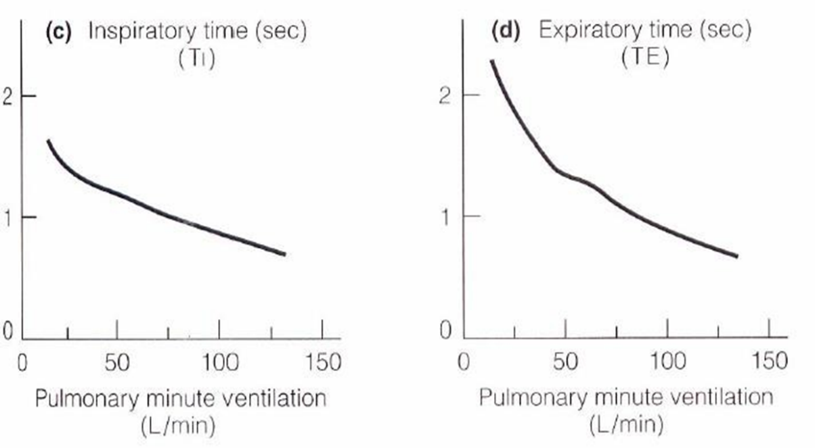

- At rest (from pic) , the time for inspiratory is slightly less than the time for expiration.
- At heavy exercising, both inspiration and expiration time are decreased. But you decrease more the time for expiration. ( The time become the same for both at heavy exercising )

- Consequently, peak expiratory flow rate increases more than peak inspiratory flow rate. ( Because you decrease the time to breath out more than decrease the time to breath in. If you decrease the time to breath out, flow will increase (everything have to go out in a shorter time))

-The next few slides is just example to prove ventilation is not limiting exercise. What limit the exercising is the cardiovascular system.

Is Ventilation a limiting factor in. aerobic performance at sea level? (VE/Q)
-Resting values of VE can increase 35 fold during exercise
(from 5L/min to 190 L/min, in a fit individual).
-Resting values of cardiac output (CO) can increase 5-6 fold during exercise (from 5L/min to 25-30 L/min, in a fit individual).
-The VE/Q = 1 at rest. Because V.E can increase more than Q during exercise, there is an increase in VE/Q. The increase in this ratio is one reason why ventilation is not believed to limit aerobic performance.
-In a less fit individual, the absolute values of VE and Q will be less but the ratio will increase to a similar extent.
-The alveolar surface area is 50m² (1/2 of a single tennis court).
-The average blood volume is 5L.
-4% of this 5L is in the pulmonary system at any one time during maximal exercise.
(200mL spread along ½ tennis court, the amount of blood is actually the limit. The respiratory system is actually not the limit.)
-Therefore, there is a large capacity for gas exchange which is another reason why ventilation is not believed to limit aerobic performance.

•In both untrained and trained subjects, minute ventilation (VE) increases linearly with metabolic rate (VO2) up to about 50% to 65% of VO2 max.
(VE increase linearly with exercising(O2 consumption), at some point here will be exaturated increase Ve.
( We said we don’t hyperventilate because metabolism and O2 consumption increase at the same time => this is true in the lower part. But when the exercising is so high, we have the exaturated increase of ventilation—not a linear increase anymore.)=> we say only at very high intensity exercising, hyperventilation.
- In trained athlete, we have a linear increase of VE as VO2, but at some point we have the exaturated increase of VE.

Take home msg: During exercise increase VE linearly, but at very high level exeturated increase of VE. Hyperventilation at high level exercise. In trained person, there is a delay , he can achieve higher level exercising before hyperventilation.
•Thereafter, VE increases at a rate disproportionately greater than the change in VO2. Note that an effect of endurance training is to delay the ventilatory inflection point (Tvent).

- Control of Ventilation during Exercise
What controls ventilation during exercise?
- Co2 sensing by the brain, so the CO2 in arterial blood influence the PH in the brain. (Does this work during exercising??)
- Graph : From rest to maximum exercising.
- Ventilation : linear increase than exeturate.
- PO2 : is maintain constant during exercise.
- PCO2 : maintain constant, drop due to the exeturated ventilation. (Co2 drop!Co2 is what drive us to breath , we do produce more CO2 by muscle in vein, but ventilation is increased before CO2 can increase in arterial blood. Also, At high level, Co2 increase! => not CO2! That control ventilation)

You don’t have a decrease PH in CSF, this can’t be the drive for you to exercise.

•During exercise, there is an alkalotic (PH increase ) response in the medullary ECF. This decreases the ventilatory response.
Therefore, the role of the central chemoreceptors is important at rest but not so much during exercise.
-could it be the chemoreceptor?
Peripheral Chemoreceptors:
•Peripheral chemoreceptors are mainly sensitive to changes in PO2, but are also stimulated by increased PCO2 and decreased pH.
- We have a constant PO2, can’t be chemoreceptor. and PCO didn’t increase
- What control ventilation during breathing is unknown.
PaO2 remains rather constant during exercise.
- PaCO2 is often seen to decrease during exercise.
- -However, during exercise, arterial pH does decrease (lactic acid) and PaO2 fluctuates subtly with arterial pulse waves. Therefore, it is possible that during exercise, these fluctuations in PaO2 increase the sensitivity of the peripheral chemoreceptors to CO2 and H⁺.
( However , people stimulate chemoreceptor by decrease the PH and didn’t see the huge increase in ventilation like in exercise. It might do to the fluctuation. These are all idea , but ppl still cant figure out why. Can by a combination of many factors.)
-The pulmonary mechanoreceptors, the muscle spindles, the Golgi tendons, and the skeletal joint receptors were thought to play a role in the increase in VE during exercise.
(they all can send a msg to the brain and stimulate centilation)
-Stimulation of these mechanoreceptors does produce an increase in VE, but it is small compared to the large and abrupt increase observed during exercise.
Onset and Recovery from Exercise

• VE is known to start increasing even before the exercise has started. This control is thought to be neural. A similar control is thought to operate at the end of exercise because a very rapid decrease in VE is observed.
- Ventilation increases right away, when we stop , ventilation decreases abruptly. Ventilation even increases before race starts ( They know to start , and VE started before head.) It is believe the start and stop is controlled neural (The brain send signal to increase, and the fine tuning during exercise is believe by neural but the source is unknown)
•Humoral control is believed to be responsible for the ventilator response during the exercise event.

-go through the important:
Static properties. Understand the properties of the lungs, the easy or difficult to inflate the lungs.
(2 balloons compare, tell if they are the same easiness to inflate) => pressure/volume relationship tell the elastic property. ( For the same pressure, which has the smaller volume.)
The stiffness: compliance.
Spirometer: measure volume
Manometer: measure pressure, the column of water move (cm of H2O)

Decrease the pressure around the balloon. In human, the pleural pressure is the one outside the lung (need to account this to tell compliance, this is measure by esophageal pressure)

-subject breath in to TLC, hold on the breath ( and measure the pressure at the mouth --- its a whole system, subject hold on breath and the pressure equilibrate to the mouth. )
From graph:
We imagine the lung is outside the body, ( forget about the pleural pressure now): we measure, record from:
- residual volume
- tidal volume
- total lung capacity
- you get a pressure volume curve ( If this is done inside the body , we need to subtract the pleural pressure at every point .)
- As you keep going up, it become harder to inflate the lungs. ( Its elastic tissue)

As the volume goes higher, the compliance decrease. (harder to inflate the lung, the compliance is the slope of the curve. The slope (compliance decrease ) as higher)
Slope (compliance) = volume change per pressure change.
------Imagine balloon, how much volume change with the pressure.
If the lung is inside body: You need to substrate the pleural pressure.
Equation become: C= V change/ ( Pal -Ppl) : pressure difference between inside and outside.
- the curve also changes in disease .
Look at the top of the curve.

- fibrosis subject (fibrotic tissue on the alveolar wall) : the stiff alveoli (hard to inflate ) , the compliance is low ( low slop)
- anthesima: floppy lung (huge change of volume) and easy to inflate but difficult to deflate.

In elderly, the stiff pf rib cage (abnormal ventilation), the difference pressure is between pleural space and outside (Poutside = 0)
- we imagine get the rib cage out of the body, hook with manometer to built the pressure volume curve.
- The rib cage is equilibrium at 60% vital capacity. (No pressure ) , different form the lung ( the lung always generate a positive pressure and tend to collapse.)
- Rib cage is a solid structure, and tend to be at 60% vital capacity => no pressure.
- Beyond the resting position, At TLC, positive pressure , rib cage want to collapse .
- At residual state (smaller volume, compress it), the rib cage want to expand (negative pressure)
- The rib cage in large volume want to collapse (generate the positive volume) in the low volume ( generate a outward force.)
Inward: positive , outward : negative
2 equations must remember:
Compliance (Cw = v/p) and resistant.

Last pic :
The curve pressure for the lung : always positive , always wants to collapse.
The curve pressure for the chest.
The TLC, is the curve for both lung and chest wall. How do we get the curve .
-Add the pressure to move the chest wall and the lung => get the TLC curve
At 60% tidal capacity: the chest is happy at equilibrium, you only need to generate the pressure for the lungs.
In FRC, the pressure of lung recoil( positive ) == The rib cage want to spring out . When you breath out, you breath to the whole respiratory volume is in equilibrium. P lung collapse =Prib expand. This is the volume of the whole respiratory system at rest = FRC definition = the equilibrium of the two.

Pneumothorax, when we remove the coupling.
- Lung go to the equilibrium position(as low as possible) ---baloon
- Rib cage spring out, it has higher equilibrium state than lung. (to a bigger volume )

